LAB ACTION PLAN FOR WEEK 11
Jenkins-CI/CD
- CI-Continous Integration using Webhooks .
- Sending E-mail Notification on Build Failure or success
- Upload the screenshots for the tasks
Lab
Setting Up Jenkins CI------using GitHub Webhook with Jenkins
Step 1: Configure Webhook in GitHub
- Go to your GitHub repository.
- Navigate to Settings → Webhooks.
- Click “Add webhook”.
- In the Payload URL field:
  - Enter the Jenkins webhook URL in the format:
http://<jenkins-server-url>/github-webhook/
Note: If Jenkins is running on localhost, GitHub cannot access it directly.
Use ngrok to expose your local Jenkins to the internet:

  - ngrok.exe http <Jenkins local host:8080>
    - Use the generated ngrok URL, e.g.:
    - http://abc123.ngrok.io/github-webhook/
- Set Content type to:
application/json
- Under “Which events would you like to trigger this webhook?”, select:
  - Just the push event
- Click “Add webhook” to save.
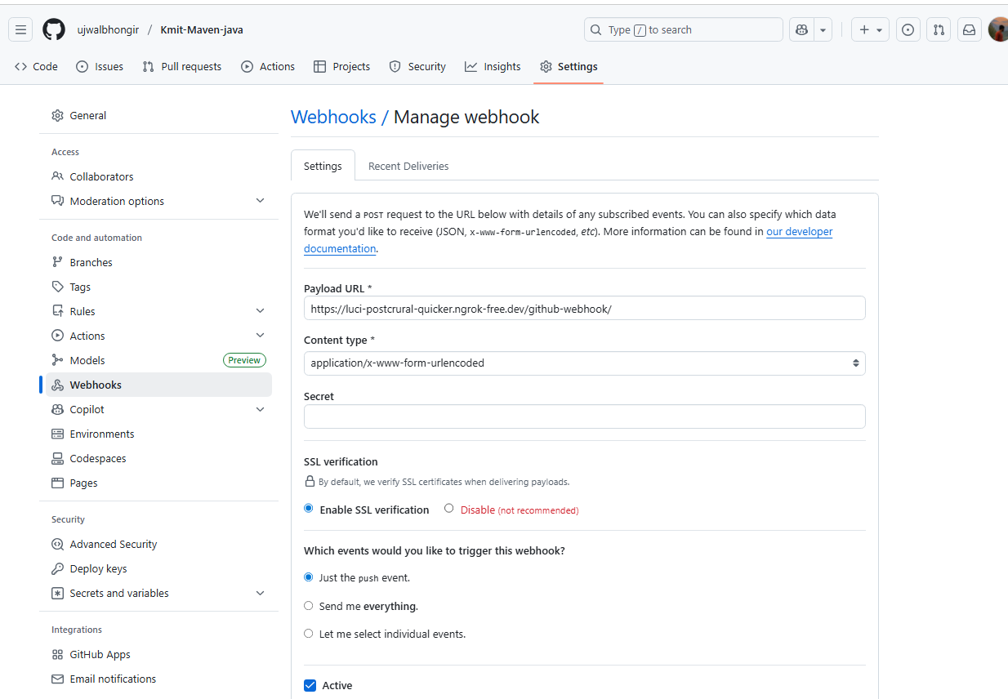

Step 2: Configure Jenkins to Accept GitHub Webhooks
- Open Jenkins Dashboard.
- Select the job (freestyle or pipeline) you’ve already created.
- Click Configure.
- Scroll down to the Build Triggers section.
- Check the box: ✅GitHub hook trigger for GITScm polling
- Click Save.
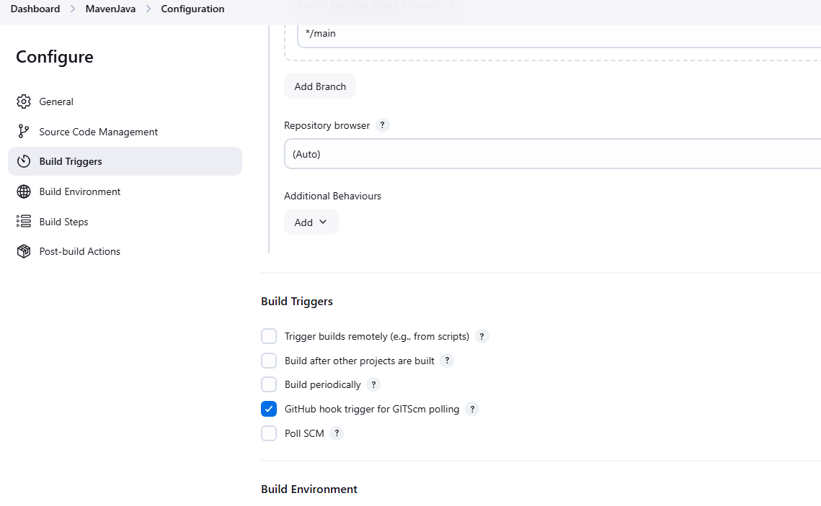

Step 3: Test the Setup
- Make any code update in your local repo and push it to GitHub.
- Once pushed, GitHub will trigger the webhook.
- Jenkins will automatically detect the change and start the build pipeline.
- Created new file “Hello.txt”
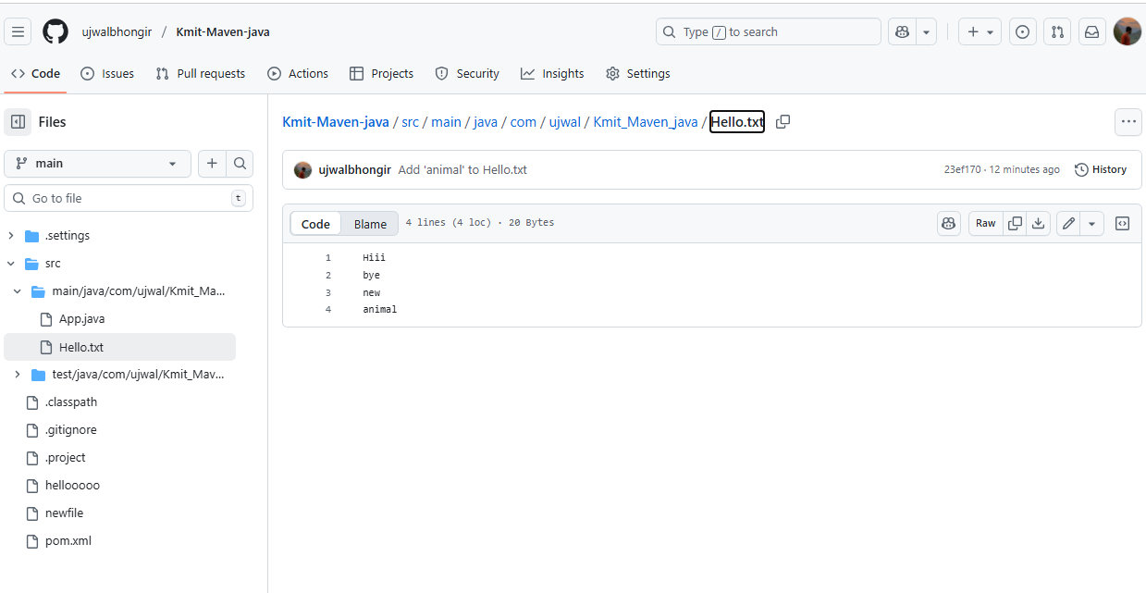

outcome
- You’ve successfully connected GitHub and Jenkins using webhooks.
- Every time you push code to GitHub, Jenkins will automatically start building your project without manual intervention.

Set-uping the ngrok

How to Install and Use ngrok

Step 1. Download ngrok
https://ngrok.com/download
Download and extract it for your OS (Windows, macOS, or Linux).

Step 2. Connect Your ngrok Account (optional but useful)
After you sign up (free), ngrok gives you an auth token.
CREATE AUTHENTICATOR [https://dashboard.ngrok.com/get-started/your-authtoken]
Run this command (replace <your_token> with yours):
ngrok config add-authtoken <your_token>

This ensures stable sessions and more control.

Step 3. Start a Tunnel for Jenkins

Assuming Jenkins runs locally on port 8085:
ngrok http 8085
You’ll see output like:

Session Status online
Forwarding https://1234abcd.ngrok.io -> http://localhost:8080
Copy the HTTPS URL (https://1234abcd.ngrok.io) — this is your public Jenkins URL for webhooks.
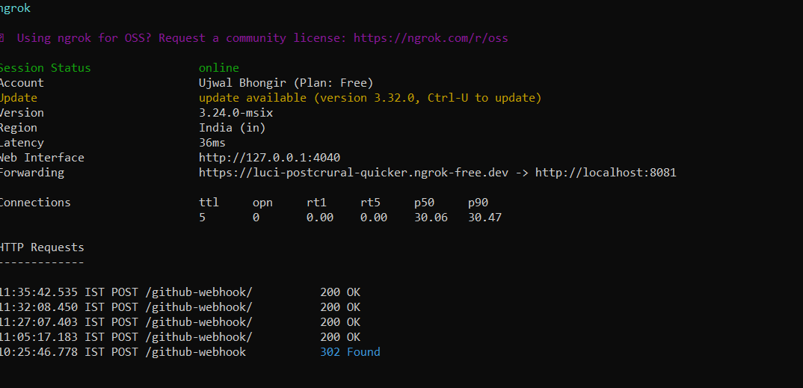
Step 4. Use it in GitHub Webhook

In your GitHub repo → Settings → Webhooks:
- Payload URL: [paste the url generated by ngrok]

https://1234abcd.ngrok.io/github-webhook/ [please include this – remaining all default]

Now, whenever you push code, GitHub sends an event to that URL, which ngrok forwards to your local Jenkins.
------------------------------------------------------------------------------------------------------------------------------------------
Setting Up Jenkins Email Notification Setup (Using Gmail with App Password)
Creation of app password
1. Gmail: Enable App Password (for 2-Step Verification)
i. Go to: https://myaccount.google.com
ii. Enable 2-Step Verification
- Navigate to:
  - Security → 2-Step Verification
  - Turn it ON
  - Complete the OTP verification process (via phone/email)
iii. Generate App Password for Jenkins
- Go to:
  - Security → App passwords
- Select:
  - App: Other (Custom name)
  - Name: Jenkins-Demo
- Click Generate
- Copy the 16-digit app password
  - 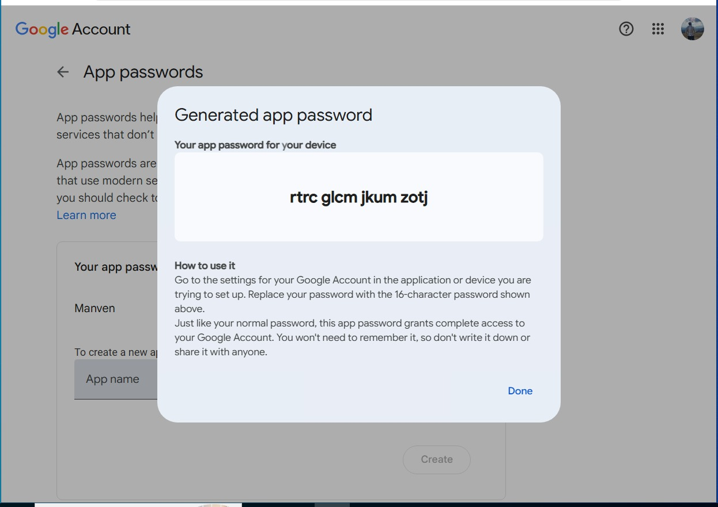Save it in a secure location (e.g., Notepad)

2. Jenkins Plugin Installation
i. Open Jenkins Dashboard
ii. Navigate to:
- Manage Jenkins → Manage Plugins
iii. Install Plugin:
- Search for and install:
  - Email Extension Plugin
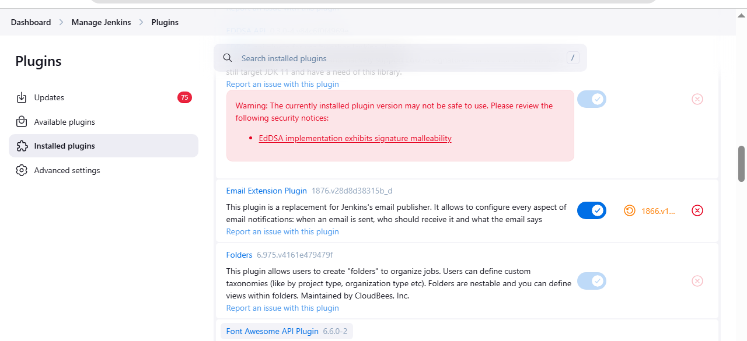

3. Configure Jenkins Global Email Settings
i. Go to:
- Manage Jenkins → Configure System

A. E-mail Notification Section
Field | Value
SMTP Server | smtp.gmail.com
Use SMTP Auth | ✅ Enabled
User Name | Your Gmail ID (e.g., archanareddykmit@gmail.com)
Password | Paste the 16-digit App Password
Use SSL | ✅ Enabled
SMTP Port | 465
Reply-To Address | Your Gmail ID (same as above)
➤ Test Configuration
- Click: Test configuration by sending test e-mail
- Provide a valid email address to receive a test mail
- ✅ Should receive email from Jenkins\
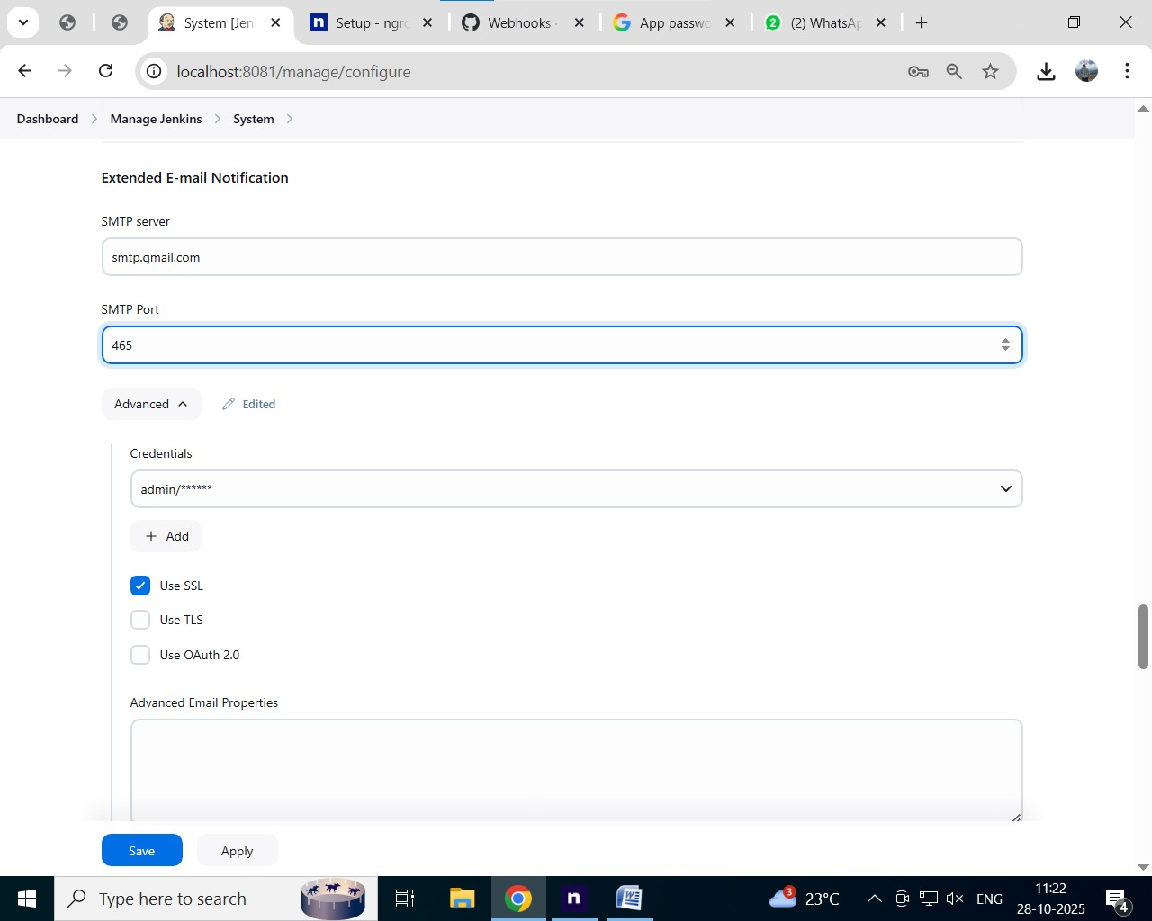

B. Extended E-mail Notification Section
Field | Value
SMTP Server | smtp.gmail.com
SMTP Port | 465
Use SSL | ✅ Enabled
Credentials | Add Gmail ID and App Password as Jenkins credentials
Default Content Type | text/html or leave default
Default Recipients | Leave empty or provide default emails
Triggers | Select as per needs (e.g., Failure)
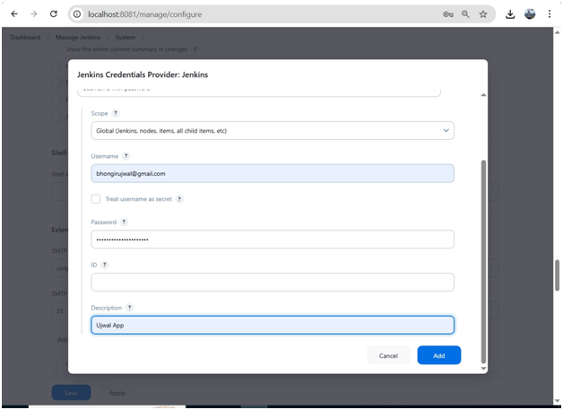

ii. In the Post-build Actions section:
- Click: Add post-build action → Editable Email Notification
A. Fill in the fields:
Field | Value
Project Recipient List | Add recipient email addresses (comma-separated)
Content Type | Default (text/plain) or text/html
Triggers | Select events (e.g., Failure, Success, etc.)
Attachments | (Optional) Add logs, reports, etc.

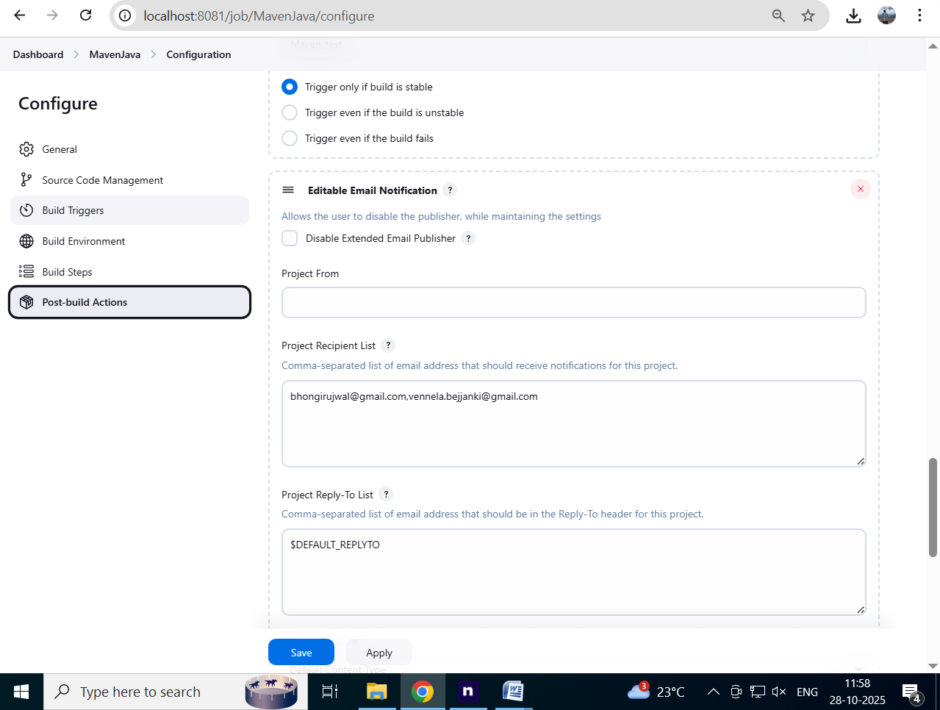

iii. Click Save

Now your Jenkins job is set up to send email notifications based on the build status!
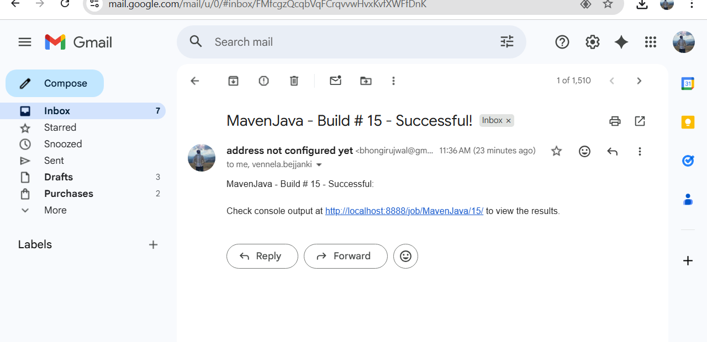

Takeaway :
Students learned how to integrate Jenkins with GitHub using webhooks to automate build triggers and configure email notifications to monitor build success or failure effectively.

TuneOra - A Music Web app
1. Sequence Diagram
A Sequence Diagram is a dynamic behavioral diagram. Unlike the other two, its purpose is to show how objects or components interact with each other over time to complete a specific task.
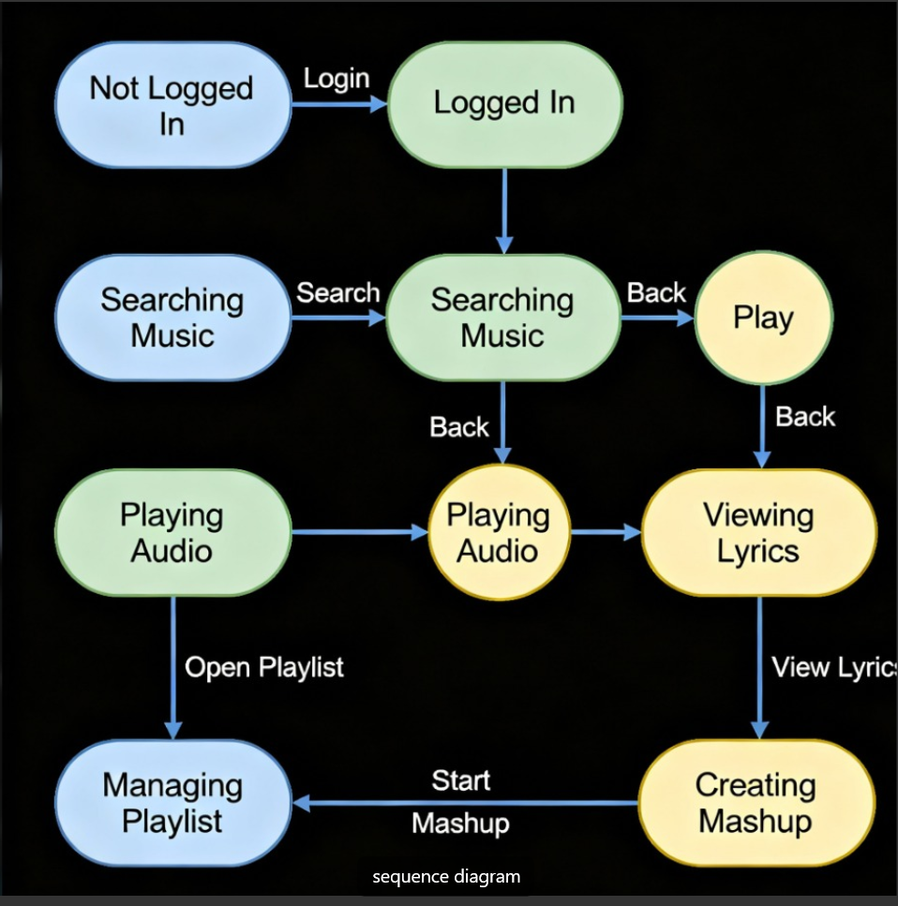

2. Class Diagram
A Class Diagram is a static structural diagram. Its main purpose is to show the structure of your system by detailing its classes, attributes, methods, and the relationships between them

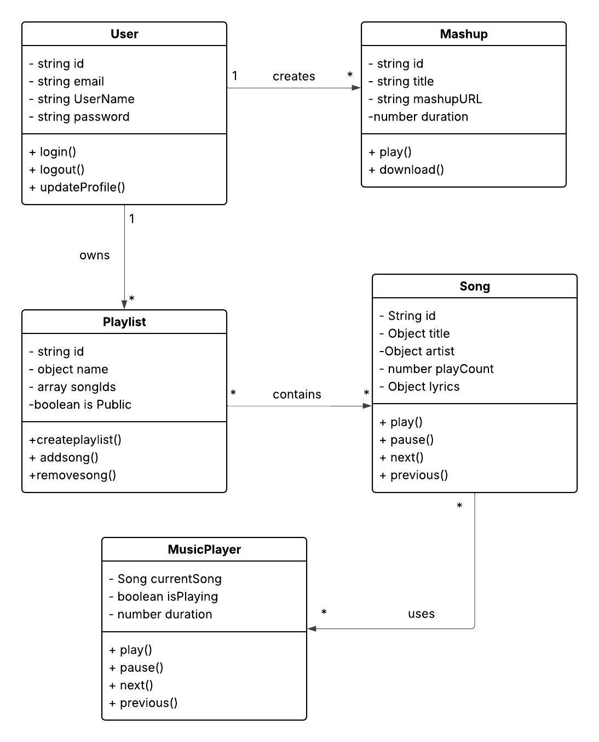

3.Component Diagram
A Component Diagram is also a static structural diagram, but it operates at a much higher level (more abstract) than a class diagram. Its purpose is to show how a system is divided into larger, modular components and how those components are wired together.
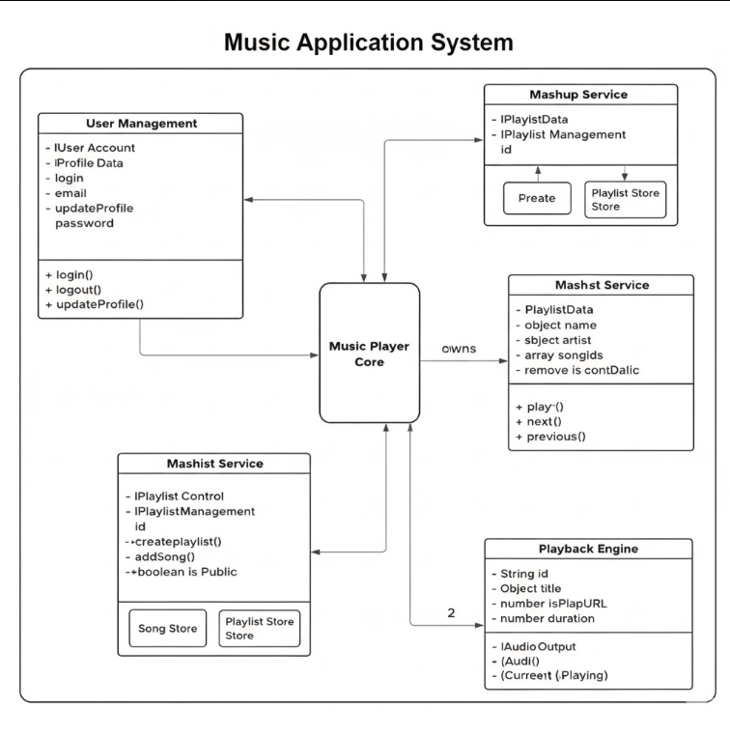

Viva Questions

1. What is Continuous Integration (CI)?
Continuous Integration (CI) is the practice of automatically building and testing code whenever developers push changes to a shared repository.
- The main goal is to detect errors early and ensure that the codebase remains stable.
- CI typically involves tools like Jenkins, GitHub Actions, or GitLab CI that automatically compile, test, and validate new code changes.

2. What is Continuous Deployment or Continuous Delivery (CD)?
Continuous Delivery (CD) and Continuous Deployment are extensions of CI:
- Continuous Delivery: The code is automatically built, tested, and prepared for release, but deployment to production requires manual approval.
- Continuous Deployment: The code changes that pass all tests are automatically deployed to production without manual intervention.
CI → CD ensures that software can be released at any time, safely and reliably.

3. What is the role of Jenkins in a CI/CD pipeline?
Jenkins is an automation server that orchestrates the CI/CD pipeline.
It performs tasks like:
- Pulling source code from repositories (e.g., GitHub)
- Building and testing the application
- Deploying the application to servers or cloud platforms
Jenkins automates and connects all stages of the development lifecycle.

4. What is a webhook in GitHub?
A GitHub webhook is a mechanism that sends real-time HTTP POST notifications to an external service (like Jenkins) whenever certain events occur in a repository — for example, when code is pushed or a pull request is created.
It “tells” Jenkins: “Hey, something just changed — start a build!”

5. Why are webhooks used in Jenkins integration?
Webhooks are used so that Jenkins doesn’t need to constantly check GitHub for changes (which is inefficient).
Instead, GitHub proactively notifies Jenkins of new commits, triggering builds instantly.
This improves speed, efficiency, and resource usage.

6. What are the different types of build triggers available in Jenkins?
Common Jenkins build triggers include:
- Build periodically – Run builds on a schedule (like a cron job).
- Poll SCM – Jenkins checks the source control (e.g., GitHub) at intervals for changes.
- GitHub webhook trigger – Trigger builds immediately when a push or PR event occurs.
- Manual trigger – A user manually starts a build.
- Build after other projects – Chain builds based on other job completions.

7. What is the difference between polling and webhook triggers?
Feature | Polling | Webhook
How it works | Jenkins checks GitHub at regular intervals for changes | GitHub sends an instant notification to Jenkins when an event happens
Speed | May delay builds until next poll | Immediate trigger
Efficiency | Uses more resources | More efficient
Network load | Periodic network requests | Event-based, minimal traffic
Webhooks are preferred because they’re faster and more efficient.

8. What is ngrok and why is it used in Jenkins–GitHub integration?
ngrok is a tool that exposes a local server (e.g., Jenkins running on localhost) to the internet through a secure tunnel.
- It provides a temporary public URL (like https://abcd1234.ngrok.io) that GitHub can send webhooks to.
Useful when Jenkins is running locally and not accessible publicly.

9. How does ngrok help in setting up webhooks for Jenkins running on a local machine?
When Jenkins runs locally (e.g., on http://localhost:8080), GitHub cannot reach it directly.
- ngrok creates a public URL that forwards requests to your local machine.
- You can then set this ngrok URL as the webhook endpoint in GitHub.
So when GitHub sends a webhook event → it reaches ngrok → which forwards it to your local Jenkins server.

10. Why do we configure email notifications in Jenkins and how are they useful for monitoring build results?
Email notifications in Jenkins automatically inform developers or DevOps engineers about build results — success, failure, or instability.
They are useful because they:
- Provide real-time feedback on build status
- Help developers quickly fix issues
- Maintain transparency across the team
Example: If a build fails, Jenkins sends an email to the developer with the build logs and error details.

